**IS COVID-19 THE DEADLIEST DISEASE?**

**BY - CHETHAN JAYA SAI**

It has been 14 months since the first-ever sample of COVID-19 was recorded. Since its appearance, the virus, SARS CoV-2 has infected millions of people worldwide. It is transmitted through the droplets generated when a person with the infection either coughs or sneezes. This is the reason behind SARS CoV-2 being the most infectious virus. If you’ve been wondering if any other viruses are as infectious as SARS CoV-2 then look at the graph below.

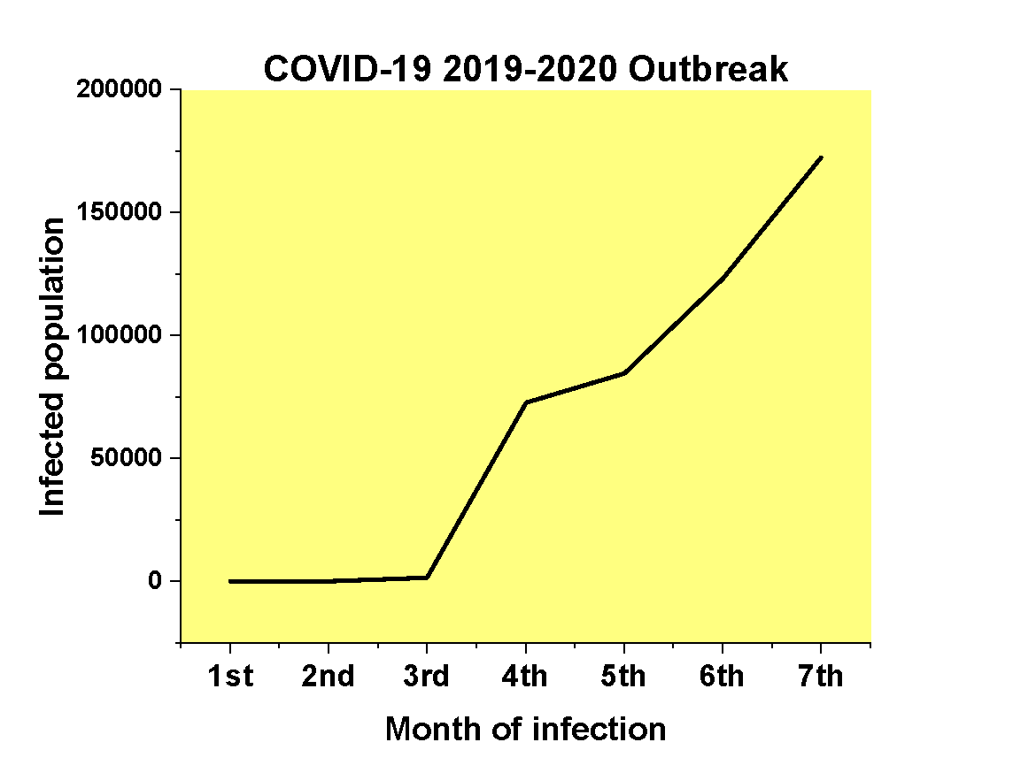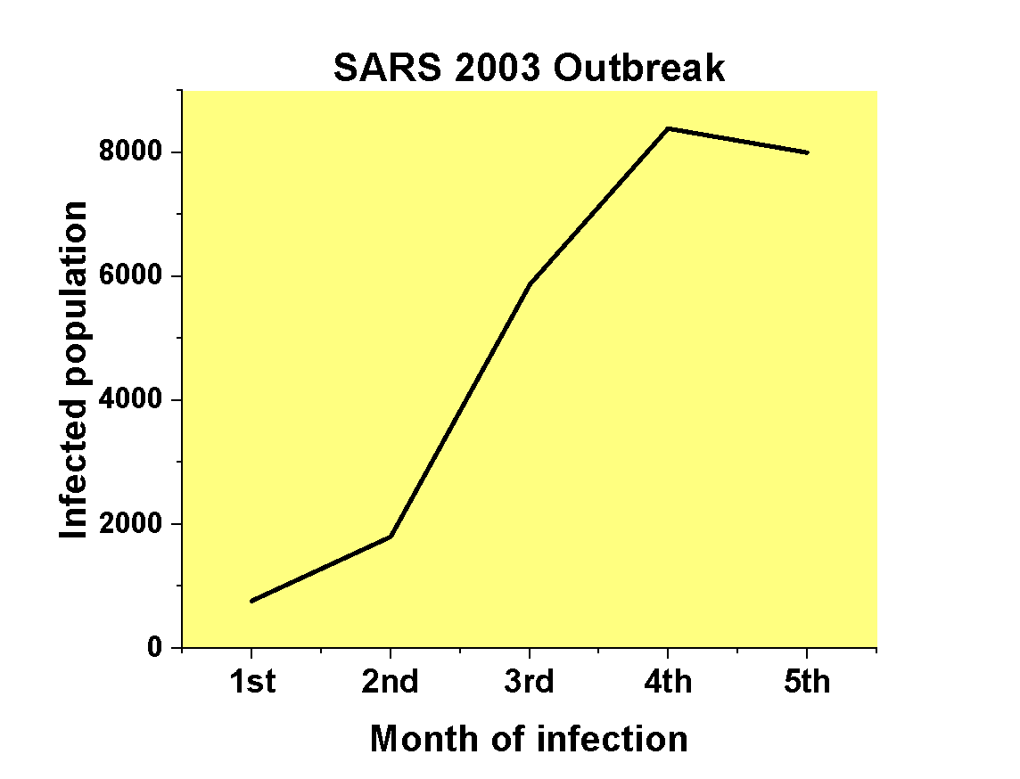

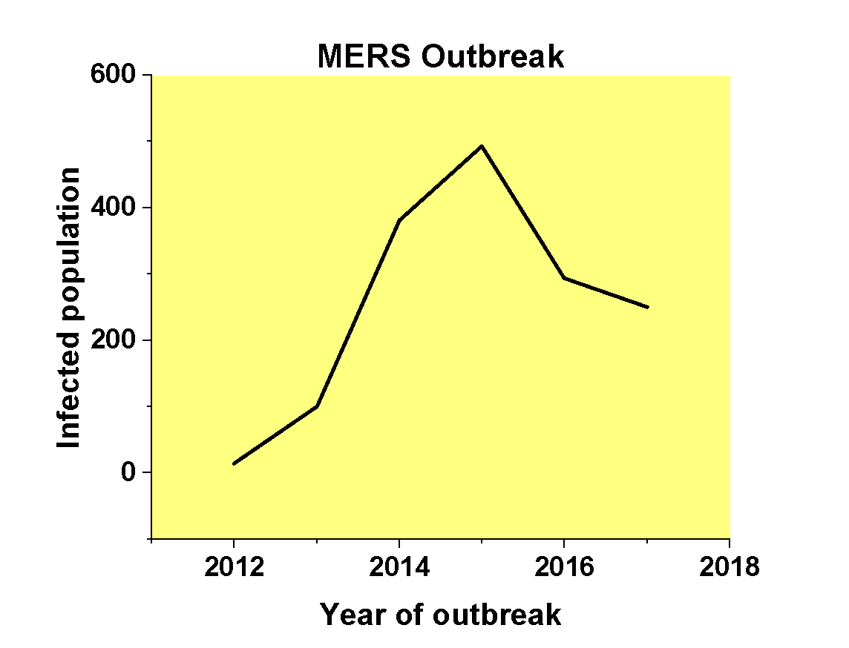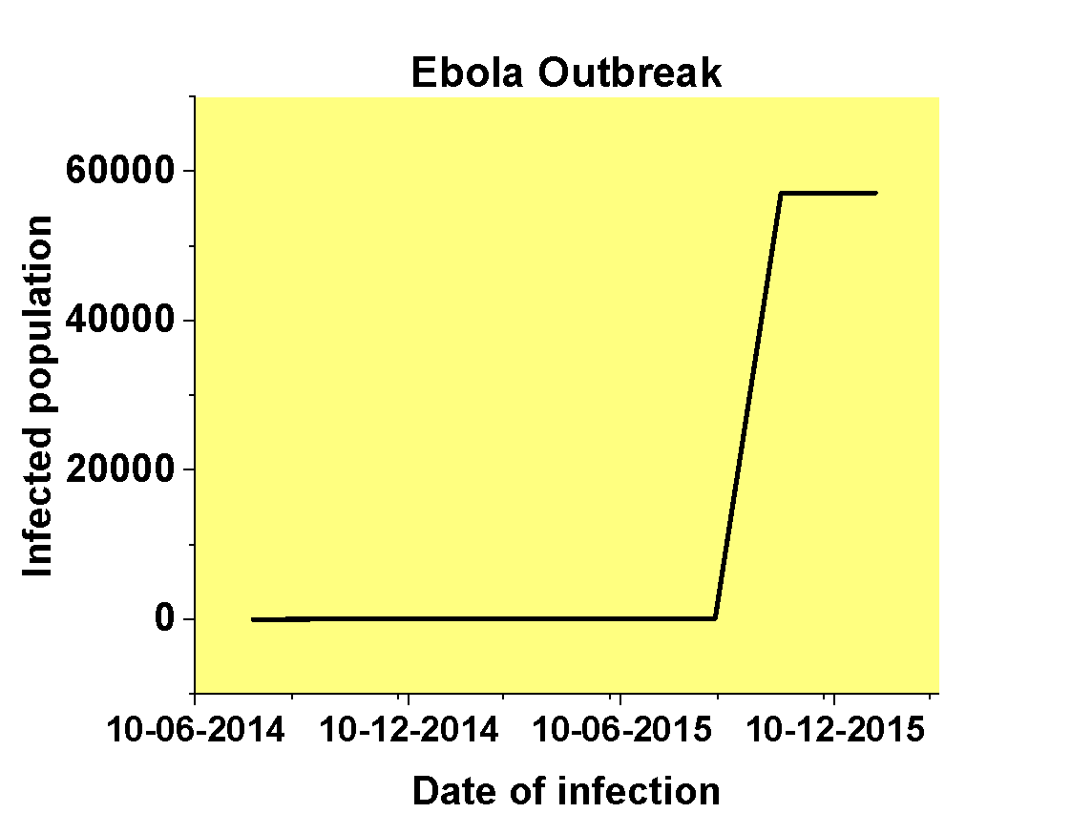

These are the graphs illustrating the progress of some major viral outbreaks in the world. They show that no other disease outbreaks can be compared to that of COVID-19 even as expressed in the X and Y-axis of the plots. If we look at the graph of COVID-19, the count of infected population crossed 150000 within the seventh month of the upsurge. Whereas the graphs show that it has taken four months for the SARS and three years for MERS to infect 8000 people and 500 people respectively after which the figures of reported cases started declining gradually. The viruses accountable for the COVID-19, SARS, and MERS diseases are SARS CoV-2, SARS CoV-1, and MERS respectively. These three viruses belong to the same family called coronaviridae. Among them, COVID-19 proves to be the most infectious.

The 4th graph shows the progress of the Ebola disease outbreak which is caused by the virus called Zaire ebolavirus. It is seen that there is a peak in the count only after a year of its first appearance in the 2014 outbreak which proves it to be the least infectious of all.

By now it is evident that the SARS CoV-2 is the virus whose rate of infection is way more than any other virus till date. Even though there isn’t any conclusion behind its highly infectious nature, many researchers say that it is stickier than the other coronaviruses. This means it firmly grasp the host cell receptors, ACE-2, and spreads faster in the body than any other coronaviruses.

Yet we can’t conclude that COVID-19 is the deadliest disease. We are still one step away. The main factor that can tell if a disease is deadly or not is its mortality rate. The mortality rate is the number of deaths divided by the total infected population. This rate indirectly gives the probability of a person recovering from a disease.

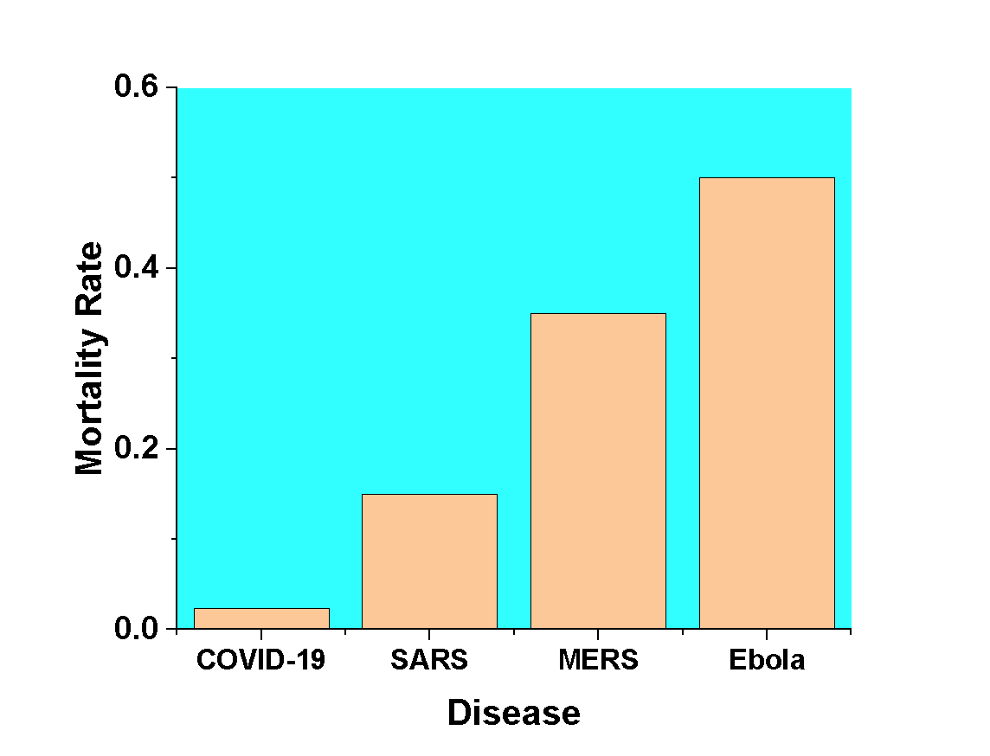

The above graph compares the mortality rates of the major diseases which caused worldwide outbreaks. The COVID-19 has the least mortality rate of 2.3% which roughly states that a person infected by this disease has a 97.7% chance of recovery. On the other hand, Ebola has a mortality rate ranging from 30% to 90% and average being 50%. People rarely survive this disease. Therefore, the analysis of all the graphs suggests that Ebola is the deadliest disease and the Zaire ebolavirus being the deadliest virus of all.

**References:**

“Template:COVID-19 Pandemic Data.” *Wikipedia*, Wikimedia Foundation, 1 Dec. 2020, en.wikipedia.org/wiki/Template:COVID-19_pandemic_data.

“Middle East Respiratory Syndrome.” *Wikipedia*, Wikimedia Foundation, 21 Nov. 2020, en.wikipedia.org/wiki/Middle_East_respiratory_syndrome.

“List of Ebola Outbreaks.” *Wikipedia*, Wikimedia Foundation, 29 Nov. 2020, en.wikipedia.org/wiki/List_of_Ebola_outbreaks.

“Western African Ebola Virus Epidemic.” *Wikipedia*, Wikimedia Foundation, 26 Nov. 2020, en.wikipedia.org/wiki/Western_African_Ebola_virus_epidemic.

“Severe Acute Respiratory Syndrome (SARS).” *World Health Organization*, World Health Organization, 23 July 2015, www.who.int/csr/don/archive/disease/severe_acute_respiratory_syndrome/en/.

By: Robert Roos  | May 07, 2003. “Estimates of SARS Death Rates Revised Upward.” *CIDRAP*, 7 May 2003, [www.cidrap.umn.edu/news-perspective/2003/05/estimates-sars-death-rates-revised-upward](http://www.cidrap.umn.edu/news-perspective/2003/05/estimates-sars-death-rates-revised-upward).